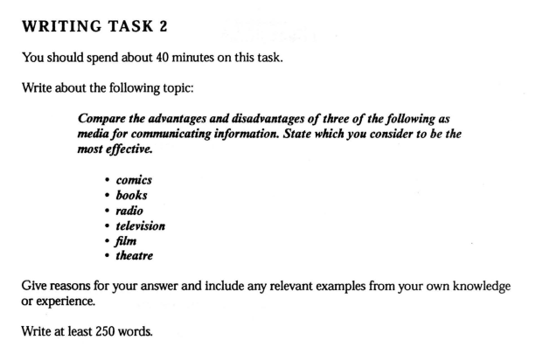

**TEST 1, WRITING TASK 2  
SAMPLE ANSWER (The Examiner’s Comments)**This is an answer written by a candidate who achieved a Band 4 score. Here is the examiner's  
comment:  
This answer describes some relevant advantages and disadvantages of books, TV and films,  
although these are sometimes unclear or not sufficiently developed. The script loses marks, however, because it doesn't answer the question about 'which medium is most effective' and also because it is under the minimum length (only 230 words).  
The writer has tried to organise ideas and uses paragraphing to structure the response. However, the message is confused at times and the answer is incomplete. Some ideas are linked appropriately, but there is a lot of repetition across sentences.  
The writer uses a limited range of language.quite repetitively and there are only simple sentences. However, these are often quite accurate, although there are many examples of basic errors in grammar and punctuation.

================

In our daily life, we always communicate information through the media, such as television, radio, film, These media have different advantages and disadvantages for us. Now, I am going to compare the advantages and disadvantages of books, Television and film.

Books bring us different knowledge. It bases on what book we read. A famous chinese traditional verse which described books is a treasure. We can find a golden house in there. Moreover, when we want to read it, we can find it easily, such as bookstore, library. We can also learn a lot of words from books. And it can improve our reading and writing skills.

However, books always are not attractive for children or youngster. It is because books are quite boring. A lot of words. and less pictures inside the books, compare to television, television has pictures and sound, we don't have to read a lot of words in television. But some artist in television programme or film,, bring a bad image to us. Then some children or youngers will imitate their behaviour. Some film also bring a wrong message to us, For example, they are always smoking in films. It seems that smoking is good and smart. It caused many youngers imitate them smoking.

In conclusion, bookds, televison and film have many advantages and disadvantages. I cannot write all in here. And we have choose the media carefully.

***I am trying to find the mistakes in the essay with the help of the examiner’s comment.***

***Paragraph 1 (An Introduction)***

1. “In our daily life, we always communicate information through the media, such as television, radio, film,”
2. In everyday life
3. “communicate information”

A candidate should not copy the question but paraphrase it.

We could write: information is typically transferred by various media.

“transfer, convey, distribute and pass on” are also collocated with “information”.

1. It should be a full stop at the end of a sentence.
2. “Now, I am going to compare the advantages and disadvantages of books, Television and film.”
3. The comma after “Now,” should be omitted.
4. “Television” should not be capitalised.
5. “compare the advantages and disadvantages”

It is not right to copy the question.

We could write: make a comparison in books, television and film.

Nowadays information is typically transferred by media such as books, film and television. In my opinion, books is undoubtly the least effective medium while television is the most . To state my point, I will make a comparison of them.

***Paragraph 2 (Body Paragraph 1)***

1. “Books bring us different knowledge”

There are broad knowledge in books.

1. “It bases on what book we read.”

It depends on what kind of books we read.

1. “A famous chinese traditional verse which described books is a treasure. We can find a golden house in there.”

* “golden” is usually for colour while “gold” it typically used for what something is made of.
* “famous” is clutterd because “proverb” means a well-known phrase or sentence.

There is treasure in books as a Chinese proverb said, “There are gold houses and charming women with striking appearence in books when you’re reading books.”.

1. “Moreover, when we want to read it, we can find it easily, such as bookstore, library.”

The pronoun should be plural when it refers to “books”.

“moreover” is not used properly here. Maybe we should use “On the other hand,”

***A Conclusion:***

*The candidate didn’t state how effecitive the books was since there is lack of logic in this body paragraph*.

***Improvement of Body paragraph 1.***

To begin with, the book is an traditional but not an effective way to propagate information even though we can buy them from bookstores or borrow them from libraries. It is time-consuming to write and to print books, which is not suitable for instant news. Whereas, there is treasure in books as a Chinese proverb said, “There are gold houses and charming women with striking appearance when you’re reading books.” Presumably, books are ideal media for stories, biographies, histories and so forth and can be read when readers want to delve into a specific field. If we want to learn about stories or histories in a more effective way, we should watch films. In addition, many people can’t receive information form books effectively. The reason is presumably they think that books are boring to read since there are substantial number of words pervading books and seldom has a book been illustrated with figures.(*from Paragraph 3*)

***Paragraph 3 (Body Paragraph 2)***

1. “However, books always are not attractive for children or youngster.”
2. “books are not alwasys attractive…”.
3. “youngster” should be plural; it is an informal word so we might use “adolescent” or “(the) youth” instead.
4. “It is because books are quite boring. A lot of words. and less pictures inside the books,”
5. It should be a full stop at the end of the sentence.
6. “It is because…” is inappropriate.
7. Improvement:

The reason is presumably they think that books are boring to read since there are substantial number of words pervading books and seldom has a book been illustrated with figures.

N.B. These sentences should be moved to the Body Paragraph 1 to support the thesis of books

***Improvement of Body Paragraph 2***

Apparently, films are more effective than books on transfering information. It is said that human beings can absord much more data by watching and listening than reading. Films are also more attractive to some extent and audiences can know about a whole story in about one and half hours, comparing one week or more to finish a book typically. Whereas, films can’t be replayed and we can watch a film once with one ticket. The best way to appreciate a classical movie is to watch it one more time. Therefore we need an alternative medium to help us.